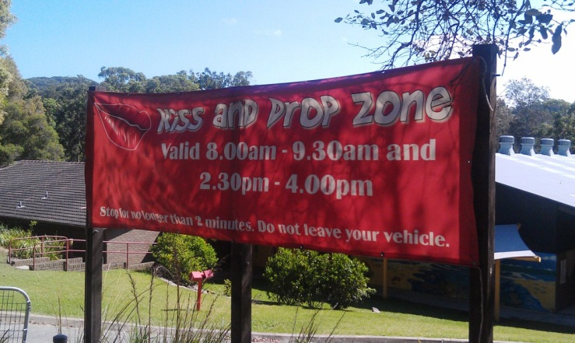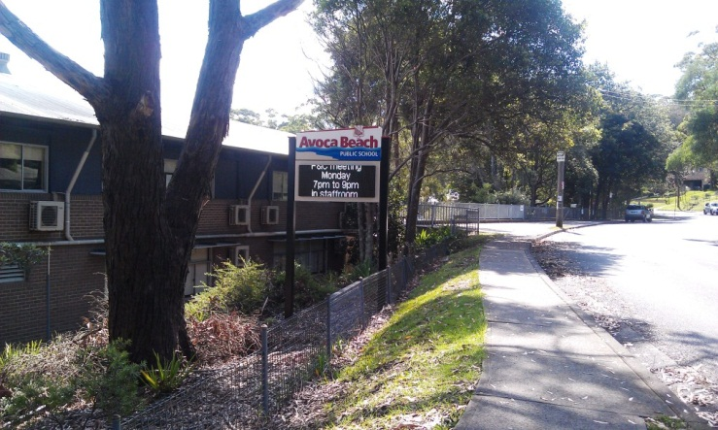

Tips for making the  
school run safer

Avoca Beach

Public School

Road Safety Education

Avoca Beach Public School is located in a residential area on The Round Drive.

Our school has a road safety education program with quality teaching and learning activities for all our students.

Parents please

* always try and meet your child on the school side of the road
* always be a role model for your children
* never call your child across the road
* never double park your car
* always obey the 40km/h speed limit

Please help support us by setting good examples, obeying all road rules and practising safe road behaviours with your children.

Angela Crowe

Principal

Road Safety Education

at

Avoca Beach Public School

Road safety practices are essential around all schools. Please read the following road safety advice specific for our school.

**2014**

Most schools experience heavy traffic congestion at school drop off and pick up times.

However it is still the responsibility of all parents and carers to ensure they follow the road rules around Avoca Beach Public School.

Parking restrictions are in place around our school to assist in the management of drop off and pick up of your children, and to increase all students’ safety.

Collect your child from inside the school gate and always use our pedestrian crossing where possible – **never call your child across The Round Drive.**

Always ensure your child enters and exits the car using the rear passenger door on the **footpath side.**

A 40km school speed zone is in place around the school to keep our students safe.

Kiss and drop zone

There is a ***No Parking Zone*** on the school side of The Round Drive for drop-off and pick-up purposes. Times of operation are from 8:00-9:30am and 2:30-4:00pm. During these times, you may only stop for up to two minutes to drop off or pick up your child. **You must NOT leave your vehicle unattended.**

Safest parking places

The Round Drive can be congested and dangerous particularly at the end of the day. Parents are encouraged to park legally on The Round Drive **south** of the school and walk with their child to and from the school gate.

No stopping and bus zones

The school *Bus Zones* are located in front of the school**.** The*No Stopping Zones* are located near our pedestrian crossing**. Drivers must NOT stop or park in both Bus and No Stopping Zones.**  Instead, park legally and walk with your child to and from the school gate.

There is a supervised pedestrian crossing on The Round Drive. Please encourage your child to cross here as this is the safest place to cross near our school.

Supervision

Until they are 8 years old, children should hold hands with an adult:

* on the footpath
* in the car park and
* when crossing the road.

Until children are 10 years old, they should still be closely supervised in the traffic environment and hold an adult’s hand when crossing the road.

Children should enter and exit your vehicle via the rear passenger door on the footpath side, as this is the safest way.

Children up to 7 years old are required to sit in an approved booster seat, with the seat belt fastened, in the back seat of the car.

The NSW Centre for Road Safety recommend that children under 12 years do **not** travel in the front seat of a vehicle.

Riding on wheels

Until children are 10 years old should cycle in a safe place off the road and away from vehicles and driveways. If children ride to school parents and carers should actively supervise them.

They are to dismount and walk their bikes through the school grounds. Bikes are to be stored in the racks near the basketball court at the owner’s risk.

If teachers are aware that a student does not have a helmet, the student will not be allowed to ride their bike home.

Penalties up to $2400 and loss of up to 7 demerit points for speeding in a school zone.

Safe car travel

Travelling to school

Where and how to park

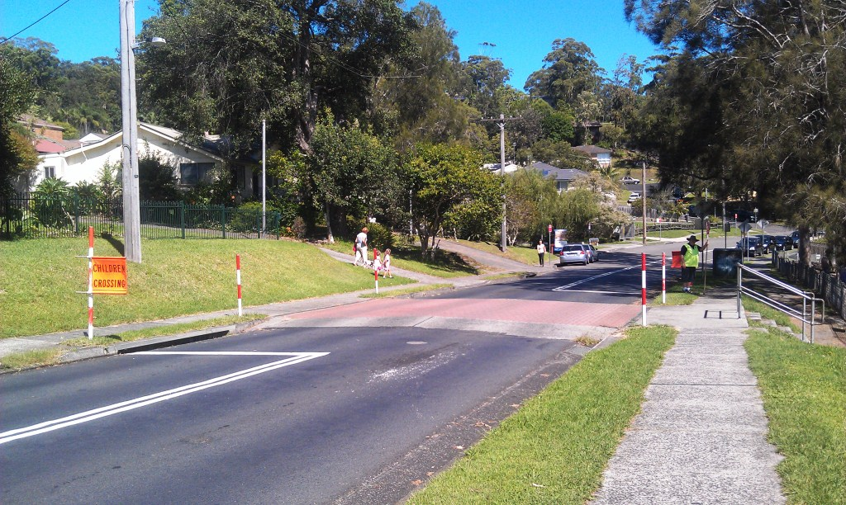

Penalties exceed $415 and  
2 demerit points for stopping  
on or near a crossing.

Penalties exceed $311 and the loss of 2 demerit points.