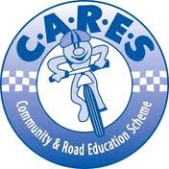

On the 4th June Class 5/6D went on an excursion to the C.A.R.E.S program in Palmdale. We got to learn about road and bike safety. In the first room we did a few activities on the smart board and we learnt a few things we didn’t know like you get fined $59 for every bike offence! The best part was when we got to have a free ride around the obstacle course which had traffic lights, pedestrian crossings, give way signs, stop signs, gravel road and a roundabout. We were given a licence with 12 points on it, and lost points each time we broke a road safety rule. We had a great day! By Charlotte and Amy - 5/6D

