Device Option 1 – iPad or iPad Mini
Please Note: Android tablets are not compatible with the Department’s internet settings so please avoid these devices.
Essential iPad apps required for BYOD
G Suite Apps - Free
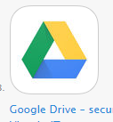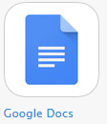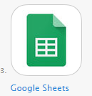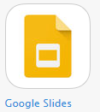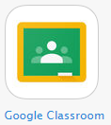
Google drive, Google docs, Google sheets, Google drive, Google classroom

Microsoft 365 Apps - free
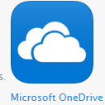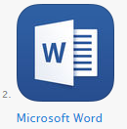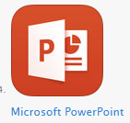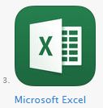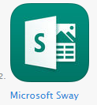
Microsoft Onedrive, Word, Powerpoint, Excel, Sway
Explain Everything - $  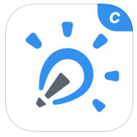 |  | Interactive whiteboard app that enables students to communicate verbally and visually. They can export their projects as video, image, pdf files. Please ensure you purchase this App as the free trial version will expire.
Google Chrome - Free  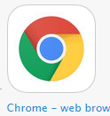 |  | The most effective internet browser for school BYOD.
Do Ink Green Screen - $  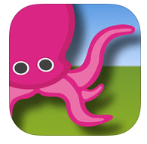 |  | Easy Green screen app
iMovie – free  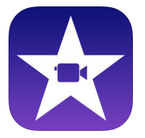 |  | Essential – can’t think of an ios alternative
Edmodo - $  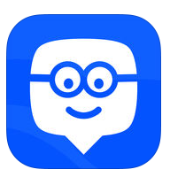 |  | Edmodo - communication, collaboration, and coaching platform to K-12 schools
See Saw - Free  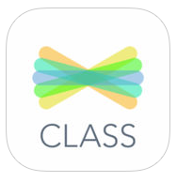 |  | Student digital portfolio
Adobe Spark - free  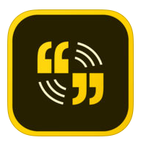 |  | Adobe spark lets you create animated videos.  *parent to set up account
Adobe Photoshop Sketch – Free  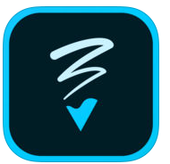 |  | Advanced drawing tool  *parent to set up account
Spehro edu – coding - free  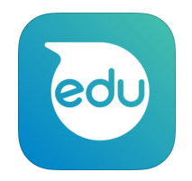 |  | Robotics App for the Sphero
Lego Mindstorms Education EV3 & WeDo 2.0  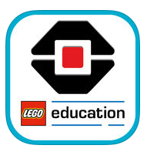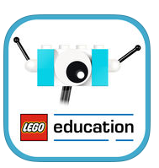 |  | Programming apps for the Lego education EV3 & WeDo robots
PicCollage and /or CANVA – both free  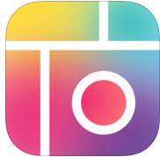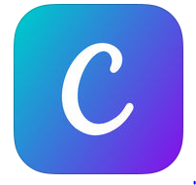 |  | For editing photos, collages, digital posters, infographics etc.
iTunes Family Sharing  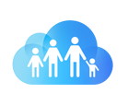 | Family Sharing makes it easy for up to six family members to share iTunes, iBooks and App Store purchases; an Apple Music family plan; and now an iCloud storage plan. TIP: if you use iCloud family sharing for apple purchases turn off photo sharing on student devices

Device Option 2 - Devices with Windows Operating System
Laptop/Netbook/Notebook/Tablet
Please Note: Android tablets are not compatible with the Department’s internet settings so please avoid these devices.
Essential software/apps required for BYOD
Microsoft 365 Apps - free
Microsoft Onedrive, Word, Powerpoint, Excel, Sway

The Department of Education and Communities has provided free access to Microsoft Office, Adobe Programs, Google Apps and Office365 to all DEC students and teachers.
Please refer to our school website for further information on how to access this free software.
http://www.avocabch-p.schools.nsw.edu.au/curriculum-activities/technology/access-free-software

Chrome - free | The most effective internet browser for school BYOD.
Movie Maker - free | Or alternative movie editing software
Explain Everything - $  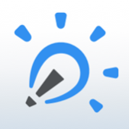 | Interactive whiteboard app that enables students to communicate verbally and visually. They can export their projects as video, image, pdf files. Please ensure you purchase this App as the free trial version will expire.
Audacity - free | Audacity or other sound recorder.
QR Code Reader  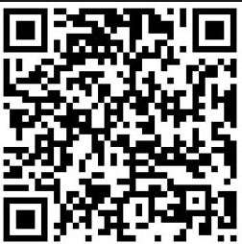 | QR Code reader
Adobe Suite (optional) - $ | The Adobe cloud offers a student plan when students register using their DET email.  firstname.lastnamenumber@education.nsw.gov.au

