BYOD Device Requirements Checklist

Wireless Connectivity

Wireless Connectivity is key to BYOD devices in schools!

Devices must support 5Ghz dual band wireless or 802.11 a/b/g/n (Make sure it supports both ‘a’ and ‘n’)

Battery Life

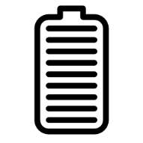
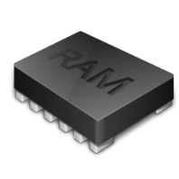
Minimum 5hrs

Devices need to last the school day, we recommend a minimum of 5hrs battery life

Memory and RAM

iPads - 16GB storage
Tablets - 64 GB storage
Laptops/Netbooks – 120 GB storage and 2 GB Ram

To be able to store and process data effectively these minimum specifications are essential

Hardware Features

Camera & Microphone

These are necessary to ensure students can participate in 21st century learning activities, a stylus or keyboard may also be useful
Screen Size

iPad Mini acceptable

Screen size no smaller than an iPad mini

Essential considerations

Casing: Needs to be tough and sturdy, can it be dropped without breaking
Weight: Is the laptop light enough for your child to carry each day?
Durability: Consider the overall durability of the device, are the keys and inputs sturdy

Accessories

Look for a tough and thick cover
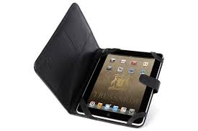

Remember this device is expected to last several years

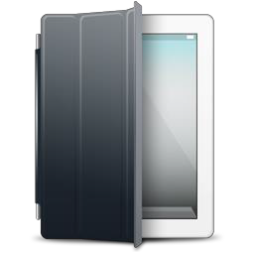
Carry Case: A carry case or skin is essential in protecting your device and can provide ergonomic advantages
Insurance: Devices can become lost or be broken easily at school, make sure your policy covers these possibilities
Warranty: Make sure you consider purchasing extra warranty to reduce future repair costs as these devices will be used extensively

