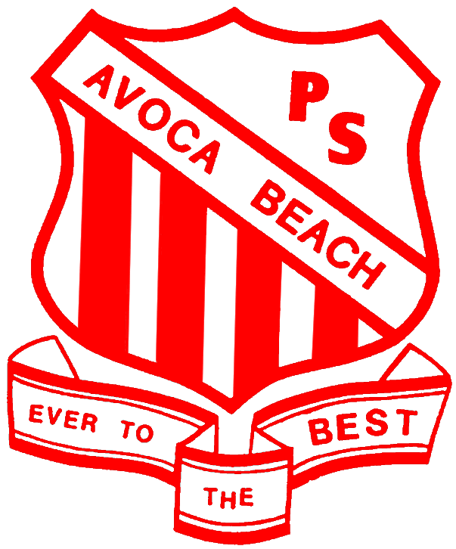
AVOCA BEACH PUBLIC SCHOOL
Providing opportunities and success in a caring, safe environment
The Round Drive, AVOCA BEACH, NSW, 2251
Ph: (02) 4382 1416 Fax: (02) 4381 1431
email: avocabch-p.school@det.nsw.edu.au website: www.avocabeach.ps.education.nsw.gov.au

6th July, 2018
Stage 1 Public Speaking Competition
Weeks 1 & 2 Term 3
Leading up to the 2018 Central Coast Public Speaking Competition (see pages 2 & 3), all students in Stage 1 are required to present a speech to their class during the first two weeks of Term 3. Presentation of individual speeches will take place on your child’s regular news day instead of news.
Students should have their prepared speeches on palm cards.
Students are free to speak about a topic of their choice, however, they are advised to avoid presenting an information style speech. Some examples of topic choice may include a family holiday, favourite animal, special event, famous person of interest or treasured memories.
Speeches are to be 1-2 minutes in length. NO PROPS are to be used.
Speeches should not be read word for word. Palm cards should provide prompts.
Students should endeavour to maintain eye contact and engage their audience.
This will be an assessment task and therefore ALL students are required to give a speech in class.
The stage finals of our Public Speaking Competition will be held on Thursday, 9th August at 10 am. Parents are most welcome to attend.
Two students will be selected to go on to the Zone Final on Thursday, 16th August at Gosford P.S.
It is expected that parents will encourage their children to complete their speech, but not write it for them.
Stage 1 Teachers
AVOCA BEACH PUBLIC SCHOOL
Providing opportunities and success in a caring, safe environment
The Round Drive, AVOCA BEACH, NSW, 2251
Ph: (02) 4382 1416 Fax: (02) 4381 1431
email: avocabch-p.school@det.nsw.edu.au website: www.avocabeach.ps.education.nsw.gov.au

6th July, 2018
2018 Central Coast Public Speaking Competition
Dear Parents and Guardians,
The 2018 Central Coast Public Speaking Competition follows on from the school level competition described on page 1. Two winners will be selected from each stage final to represent Avoca Beach Public School in the Central Coast Primary Schools Public Speaking Competition to be held on date Thursday, 16th August 2018.
This competition places no rigid restrictions on topic choices. Students are free to speak about a topic of their choice, however they will be advised to avoid presenting an informational style speech. Students should have their prepared speeches on palm cards.
Please note the following timeline of events:
- Class finalists determined by teachers by the end of Week 2 Term 3.
- Two representatives from each class will deliver their speeches in a stage final Week 3 Term 3.
- Two winners from each stage will be selected to represent Avoca Beach Public School in the Central Coast Public Speaking Competition to be held on Thursday 16th August, 2018.
Speaking times for prepared speeches:
Early Stage 1 (Kindergarten) | 1 minute
Stage 1 (Years 1 and 2) | 1-2 minutes
Stage 2 (Years 3 and 4) | 2-3 minutes
Stage 3 (Years 5 and 6) | 3-4 minutes

See next page for competition rules.

Rules of Central Coast Public Speaking Competition:

- Timekeepers will be used to ensure time limits are not exceeded.
- Students are permitted to select their own topics.
- No props are to be used.
- A microphone will be available on stage for students to use if they choose.
- Students must wear full school uniform.

Adjudication Criteria:
- Creativity/Originality of Introduction /10
- Content /20
- Method - Sustained audience engagement /30
(humour, audience response)
- Presentation /30
(enthusiasm, stance, spontaneity and naturalness of gestures,
NO PROPS)
- Creativity/originality of conclusion /10
TOTAL /100

